**Student Name: Amanda Murphy**

**Access Code (located on the underside of the lid of your lab kit): No lab kit, using own materials with Straighter line permission**

**Pre-Lab Questions”**

1. Explain how the First Law of Thermodynamics relates to metabolism in humans.  
   **Through the First Law of Thermodynamics metabolism in humans is defined as the process through which food is converted into energy for the human body to consume for activities. Metabolism of the human body is a prime example of the first law of thermodynamics in action.**
2. When does work have a positive magnitude in the equation for the first law of thermodynamics? When is it negative?  
   **In the equation for the first law of thermodynamics work has a positive magnitude when the system does work on its surrounding such as gas in a balloon pushing against the rubber causing it to expand. It is negative when the work is internal or an outside force is causing the gas to compress or shrink inwardly.**
3. A thermodynamic process that maintains a constant volume is called an **isochoric process**. During these types of processes, the gas does no work because it is not increasing the volume of the container. If you sealed off the top of a water bottle and shook 100 mL of water for two minutes, you would find that the water is warmer when you take a drink. If you shook the water long enough to raise the water’s temperature 5 ºC, what is the change in internal energy of the system?  
   **The kinetic energy of the water molecules is increasing which is in turn causing the temperature of the water to increase.**
4. When you put a few drops of food coloring in water, the molecules of food coloring will eventually diffuse throughout the whole glass. Use the Second Law of Thermodynamics to explain why the entropy of the diffused food coloring is greater than when you initially drop the food coloring into the water.  
   **When a drop of food coloring is added to water the color is concentrated in the one space but overtime the molecules of the water diffuse the food color until the concentration lowers as the color spreads throughout the whole container of water.**
5. If you roll two dice of different colors, the sum of the individual dice can be equal to the numbers 2 through 12. The sum of the dice is the **macrostate** of this system. The numbers on each individual die is equal to the **microstate** of the system. For example, if you roll a white and black die and the white lands on a 3 and the black die lands on a 4, then the microstate of the system is “3 and 4” while the macrostate is “7”. Given this information, complete Table 1. A macrostate of 3 has been completed for you (dice images are included as a visual aid).

Table 1: Possible Microstate Data for 2 Dice

|  |  |  |  |
| --- | --- | --- | --- |
| Macrostate | Possible Microstates  (Dice Combinations) | Number of Microstates, Ω | Entropy S= k ln(Ω) |
| 2 | **1 black and 1 white** | **1** | **4.8 x 10^-24** |
| 3 |  | 2 | 9.6 x 10-24 |
| 4 | **(1,3), (2,2), (3,1)** | **3** | **15.4 x 10^-24** |
| 5 | **(1,4), (2,3), (3,2), (4,1)** | **4** | **19.2 x 10^-24** |
| 6 | **(1, 5), (2,4), (3,3), (4,2), (5, 1)** | **5** | **25 x 10^-24** |
| 7 | **(1, 6), (2, 5), (3,4), (4,3), (5, 2), (6,1)** | **6** | **30.8 x 10^-24** |
| 8 | **(2,6), (3,5), (4,4), (5,3), (6,2)** | **5** | **25 x 10^-24** |
| 9 | **(3, 6), (4,5), (5,4), (6,3)** | **4** | **19.2 x 10^-24** |
| 10 | **(4,6), (5,5), (6,4)** | **3** | **15.4 x 10^-24** |
| 11 | **(5,6), (6,5)** | **2** | **9.6 x 10^-24** |
| 12 | **(6,6)** | **1** | **4.8 x 10^-24** |

1. Once you know the number of possible microstates, you can determine the probability of obtaining a certain macrostate. The probability of a macrostate, Pmacro, is equal to the possible microstates for a given macrostate divided by the total number of possible microstate combinations.

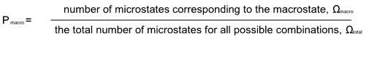

For example, the probability of rolling a 3, P3, is equal to 5.6%:

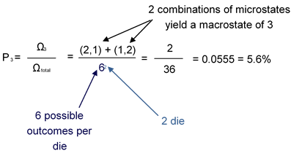

Given this information, complete and graph Table 2.

Table 2: Dice Macrostates Probability Data

|  |  |
| --- | --- |
| Macrostate | Probability of Rolling a Macrostate |
| 2 | **2.8%** |
| 3 | **5.6%** |
| 4 | **8.3%** |
| 5 | **11.1%** |
| 6 | **13.9%** |
| 7 | **16.7%** |
| 8 | **13.9%** |
| 9 | **11.1%** |
| 10 | **8.3%** |
| 11 | **5.6%** |
| 12 | **2.8%** |

Handwrite your name next to your graph.  
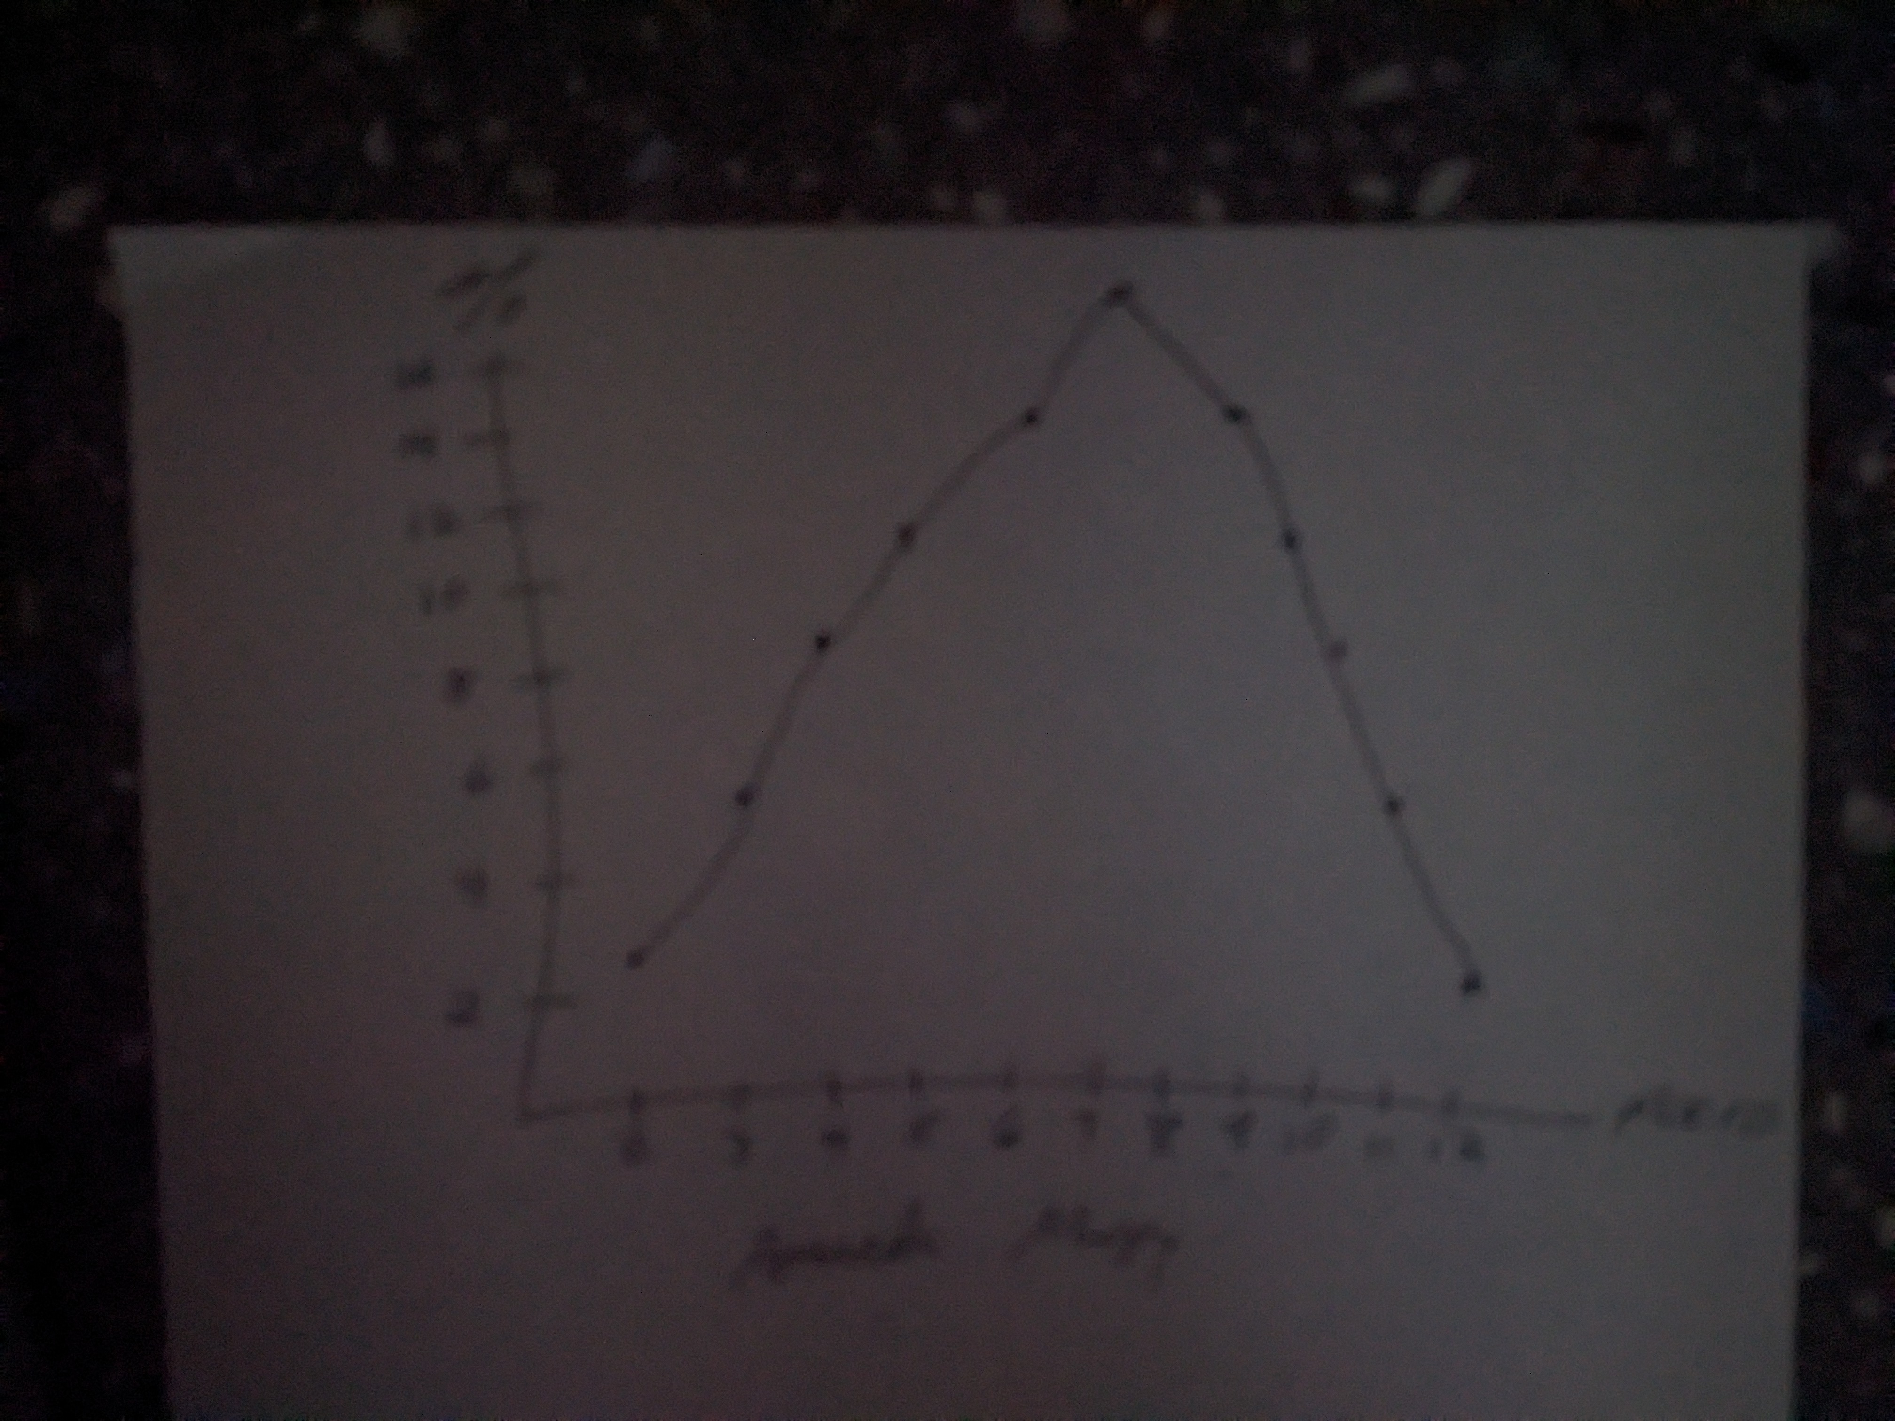

# **Experiment 1: first law of thermodynamics**

## Post-Lab Questions

1. What did you observe as heat was added to the system over time? What did you observe as the system cooled down?  
   **As the heat was increased the balloon began to inflate but once the temperature started cooling again the balloon deflated back down to starting point.**
2. Consider the balloon and air inside the flask to be a closed system. Use the First Law of Thermodynamics to explain what happened to the balloon as heat was added by the environment.   
   **Through the first law of thermodynamics heat is a form of energy that can be transferred between the surrounding environment to the closed system of the ballon causing it to react to the increased heat and energy which lead to the expansion of the balloon.**
3. Was the work done on the system positive or negative? Use your results to support your answer.  
   **Heat transfer to a system is positive, so increasing the temperature surrounding the flask causing the balloon to expand was a positive work and allowing it to cool back to room temperature was negative because it took away the work of the heat.**

**Take a photo of your Strofoam® cups taped together. Be sure to have your name handwritten in the background of the photo**.   
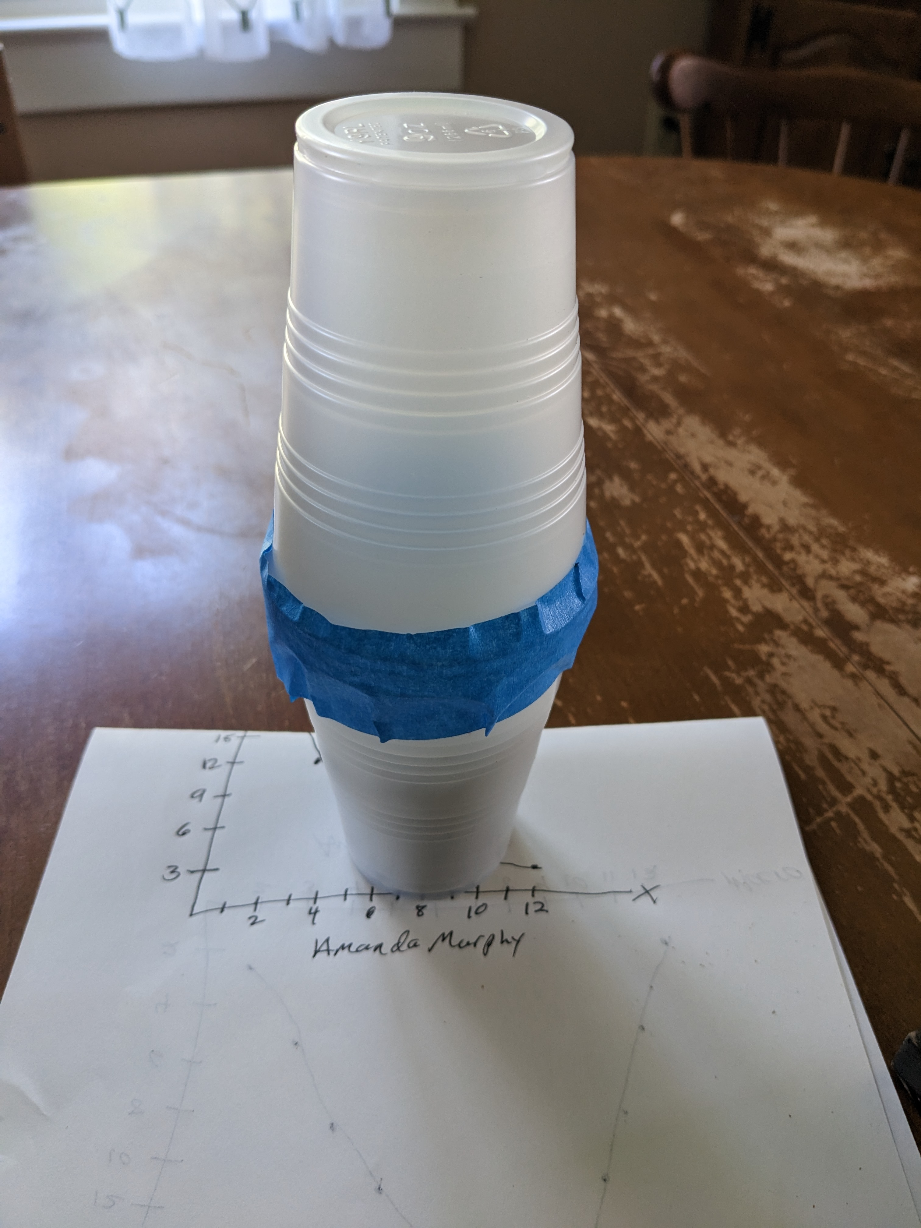

# **Experiment 2: Shaken sand system**

## Data Sheet

Table 1: Shaken Sand System Temperature Data

|  |  |
| --- | --- |
| Initial Temperature (ºC) | 24.4 |
| Final Temperature (ºC) | **24.4 is initial, 29.8 was final (upper box not working)** |

## Post-Lab Questions

1. What was the temperature change of the sand? Show your work.  
   **29.8-24.4 = 5.4 degrees celsius**
2. What was the change in internal energy of the system? Show your work. **Hint**: The specific heat for dry sand is about 0.80 J/g·K and the density for sand is 2.3 g/mL.  
   5.4(.8)/2.3 =1.88
3. Explain where the heat energy is coming from, if there is no work being done on the system because the volume is constant.  
   **The heat energy is coming from the friction of the motion being exerted with the sand being shaken in a closed container. The tight space and constant motion cause the friction to increase thus raising the internal temperature of the sand from the work and energy being done.**

# **Experiment 3: heat flow**

## Post-Lab Questions

1. Describe the feeling you experienced when you placed your finger in the room temperature water after it was in the warm water.  
   **The room temperature cup felt cold. My finger was warm from the hot water and putting in the room temp cup immediately after made that cup feel cold.**
2. Describe the feeling you experienced when you placed your finger in the room temperature water after it was in the ice water.  
   **The room temperature cup felt warm. My finger was cold from the ice and it had a nice warming experience placing it in the other cup.**
3. After you put your finger in the room temperature water, describe the flow of heat for the finger that was originally in the hot water.   
   **The heat that was still in my finger from the hot water seemed to flow outward from my finger into the surrounding room temp water.**
4. After you put your finger in the room temperature water, describe the flow of heat for the finger that was originally in the cold water.   
   **It felt like the flow of heat from the warmer water was coming into my finger to warm it after experiencing the cold.**
5. According to the Second Law of Thermodynamics, your finger will not gain the heat it lost once you put it into the room temperature water, but eventually your hand does warm back up. Why?  
   **Because water conducts hot and cold temperatures better than human skin.**

# **Experiment 4: probability of states**

## Data Sheet

Table 3: Dice Macrostate Probability Data – 100 Trials

|  |  |  |
| --- | --- | --- |
| Macrostate | Number of Occurrences | Total Occurrences |
| 2 | **lll** | **3** |
| 3 | **lllll** | **5** |
| 4 | **llll** | **4** |
| 5 | **lllll ll** | **7** |
| 6 | **lllll llll** | **9** |
| 7 | **lllll lllll lllll l** | **16** |
| 8 | **lllll lllll llll** | **14** |
| 9 | **lllll lllll lllll ll** | **17** |
| 10 | **lllll lllll ll** | **12** |
| 11 | **lllll lllll** | **9** |
| 12 | **llll** | **4** |

## Post-Lab Questions

1. Create a graph of the number of occurrences with the corresponding macrostate. How does this graph compare to the graph you created in Pre-Lab Question 3?   
   Handwrite your name next to your graph.  
   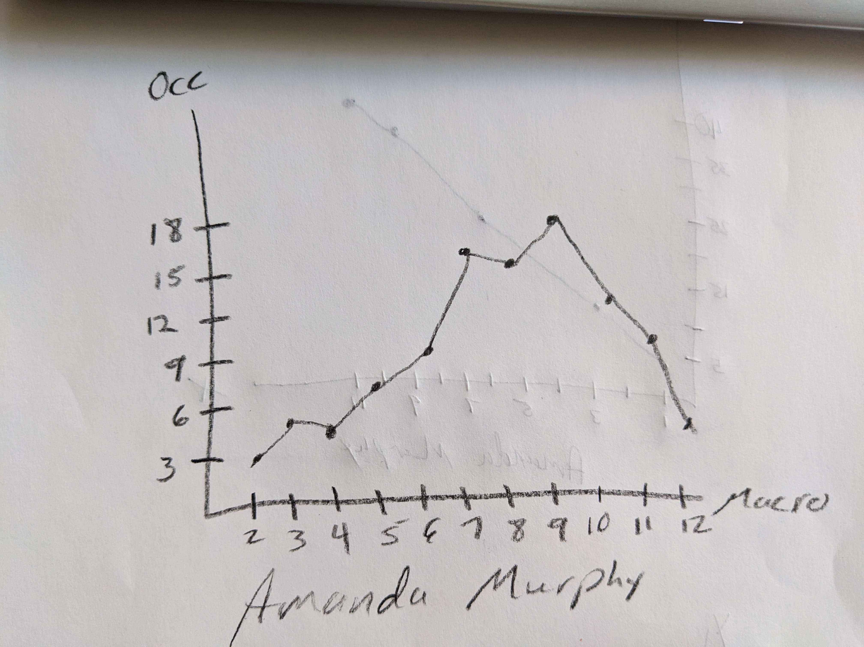
2. Given your data for one hundred rolls, calculate the probability of rolling one specific macrostate. How does this compare to the percentages you calculated in Pre-Lab Question 3?  
   **12/36 = .33 which is higher than percentages calculated in pre lab questions.**
3. If you repeated this experiment four times, would you expect similar results? Why or why not?  
   **I would expect the results to be similar though not the exact same. The basic trend is the same as the pre lab questions where the numbers with more macros occure more often while the others are less frequent. In chance there are definitely variations to this rule that take place the the general shape of the graph remains in tact.**
4. How would your results be different if you rolled the dice fifty times? Five hundred times?  
   **I expect the results to be the same generally. There will always be times that chance makes the results vary slightly but overall the odds are still greater to roll the higher macro numbers more frequently than the lower ones.**